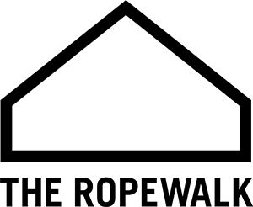
Standing Order Form

To:
Name of Bank
Branch Address
Town |  | Postcode
From:
Title |  | First name(s)
Surname
Home Address
Home Address |  |  |  | Postcode
Email
Donation Details:
Please pay the sum of | £ | every week month year  please tick one
Account name
Sort code |  |  | Account number
Date of first payment | _ _ / _ _ / _ _ _ _ |  | Date of last payment |  | _ _ / _ _ / _ _ _ _
To this account | The Ropewalk (Barton). Registered Charity No. 1194056  Lloyds Bank. Sort Code – 30-96-26. Account No. – 72235768
Signature |  |  |  |  | Date
Boost your donation by 25p of Gift Aid for every £1 you donate! Gift Aid is reclaimed by the charity from the tax you pay for the current tax year. Your home address is needed to identify you as a current UK tax payer |  |  |  | In order to Gift Aid your donation you must tick the box below  I want to Gift Aid my donation
I am a UK taxpayer and understand that if I pay less Income Tax and/or Capital Gains Tax in the current tax year than the amount of Gift Aid claimed on all my donations, it is my responsibility to pay any difference.
Please notify us if you:

- Want to cancel this declaration
- Change your name or home address
- No longer pay sufficient tax on your income and/or capital gains to sustain gift Aid on this donation

If you pay Income Tax at the higher or additional rate and want to receive the additional tax relief due to you, you must include all your Gift Aid declarations on your Self-Assessment Tax Return or ask HM Revenue & Customs to adjust your tax code.

Please return this form to:

The Ropewalk, Maltkiln Road, Barton upon Humber, North Lincolnshire. DN18 5JT.

