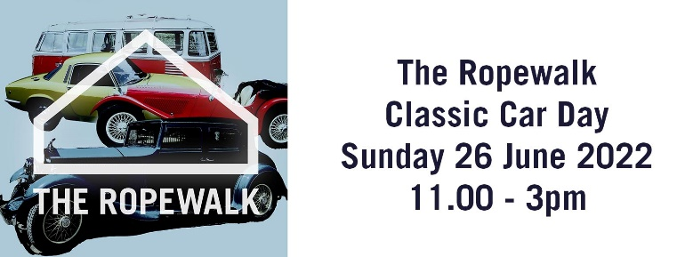

VEHICLE ENTRY FORM
(please use block capitals)
Name of Owner:
Address:
Postcode:
Telephone No.:
Email:
Vehicle Make: Model:
Year: | Reg. No.:
Colour:

CONDITIONS OF ENTRY (TO BE READ AND SIGNED)

- All vehicles are to be in place before the show opening time. No vehicles are to be moved or to leave the show before the closing time unless agreed and escorted by a show official or marshal.
- No engines to be started or run whilst the show is in progress.
- All entrants must comply with the official’s or marshal’s directions.
- Max speed 10mph on site.
- All vehicles must comply with the Road Traffic Acts and must be in a presentable condition.

I understand that the officers and the organisers of this event and/or their representatives will not accept any responsibility for any loss or damage to any vehicle or persons while attending the event. I agree to comply with above Conditions of Entry and to comply with the request of any official whilst I am on the site.

I confirm that my vehicle is covered by Third Party insurance.

Signed:

Date:

Post to: The Ropewalk, Maltkiln Road, Barton upon Humber North Lincolnshire DN18 5JT • Tel: 01652 660380 or Email events@the-ropewalk.co.uk
Closing Date for entries: 10th June 2022

