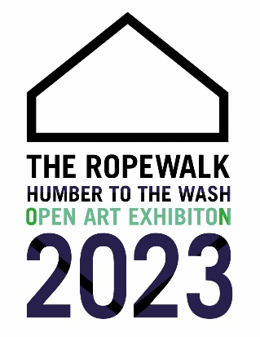
Sponsored by
INFORMATION FOR ARTISTS

JUNE 10 – SEPTEMBER 3 2023
Open to all artists who live or work in the counties of East Yorkshire (including Hull), North Lincolnshire, North East Lincolnshire, Lincolnshire and Norfolk.
Works can be on any theme and in any medium.

Submission
Artists can submit up to a maximum of 4 works. There is an entry fee of £5 per work. This fee is non-returnable regardless of whether your work is accepted or not. Payment is by cash or card on delivery of works. (Card payments must be made at the Craft Gallery reception prior to delivery).

Complete the Entry Forms carefully using Block Capitals (this information is used for the catalogue).
The Gallery Copy of the Entry Form should be handed in on delivery of works.
The Artist’s Copy should be retained for your records. Label 1 should be attached to the reverse of the work. Label 2 should be tied to the back of the work with a piece of string long enough to allow the label to reach over and be read from the front.

Framing
Each two-dimensional entry must be framed and mirror plated in a central position on the vertical edges. Clip frames or diffused glass will not be accepted. Three-dimensional works if not wall mounted must be self-supporting and marked fragile if appropriate.

Submission Dates
Friday 26 May 10am - 5pm Saturday 27 May 10am - 5pm Sunday 28 May 10am - 4pm
Monday 29 May 10am - 4pm
All work should be unpacked on delivery and the packing taken away.

Selection and Preview
Selection will take place on Wednesday May 31. There will be a preview on Thursday June 8 between 6pm and 8pm
There will be a selection panel of 2 guest selectors:
Nigel Walker Artist Victoria Bissett Ropewalk Trustee
The selectors’ decision is final and no correspondence will be entered into regarding the selection.

After Selection
All entrants will be notified by email of the selectors’ decision.
All non-selected work will be available for collection from 13 June 2023. After the exhibition closes accepted work may be collected between Tuesday 12 September and Sunday 24 September

Sales
All works must be for sale and the price indicated on the entry form must be the selling price. The Gallery will then deduct a commission of 40% plus VAT.
Copyright
All works must be original and the artist’s own work.

Insurance
Works are submitted at the owner’s risk. The Ropewalk shall not be liable for loss, damage, howsoever caused, during transport, storage or selection. It is the responsibility of the artist to arrange proper and adequate cover against these risks. All works selected for exhibition will be insured under the Gallery’s existing policy, from the time of selection to the time of collection following the exhibition’s closure.

Prizes
There will be a selectors' prize of £500. Other prizes to be announced.
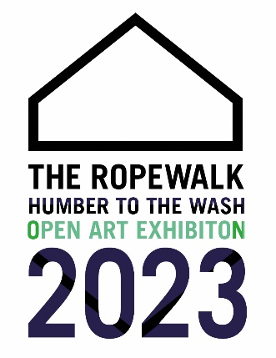
Entry Form

Gallery Copy
Please complete and hand in on delivery
NAME
ADDRESS
POSTCODE

TEL. NO. (HOME)

TEL. NO. (MOB)
EMAIL

TITLE 1
Medium
Price £
TITLE 2
Medium
Price £
TITLE 3
Medium
Price £
TITLE 4
Medium
Price £
The Ropewalk • Maltkiln Road • Barton upon Humber • North Lincolnshire • DN18 5JT •
01652 660380 • www.the-ropewalk.co.uk • Email: info@the-ropewalk.co.uk

EMAIL
Entry Form

Artist Copy
Please complete and hand in on delivery
NAME
ADDRESS
POSTCODE

TEL. NO. (HOME)

TEL. NO. (MOB)

TITLE 1
Medium
Price £
TITLE 2
Medium
Price £
TITLE 3
Medium
Price £
TITLE 4
Medium
Price £

The Ropewalk • Maltkiln Road • Barton upon Humber • North Lincolnshire • DN18 5JT •
01652 660380 • www.the-ropewalk.co.uk • Email: info@the-ropewalk.co.uk
Labels 1: Please cut out and attach to back of works
Name
Title 1
Medium
Price £

Name
Title 2
Medium
Price £

Name
Title 3
Medium
Price £

Name
Title 4
Medium
Price £

Labels 2: Please cut out and TIE to back of works with a piece of string long enough to allow the label to reach over and be read from the front. You may wish to print on or stick to a stiff card.
Name
Title 1
Medium
Price £
Name
Title 2
Medium
Price £
Name
Title 3
Medium
Price £
Name
Title 4
Medium
Price £

